
Egypt Centre Information Sheet

Glass bracelet fragments
EC1155–EC1181
Islamic Period

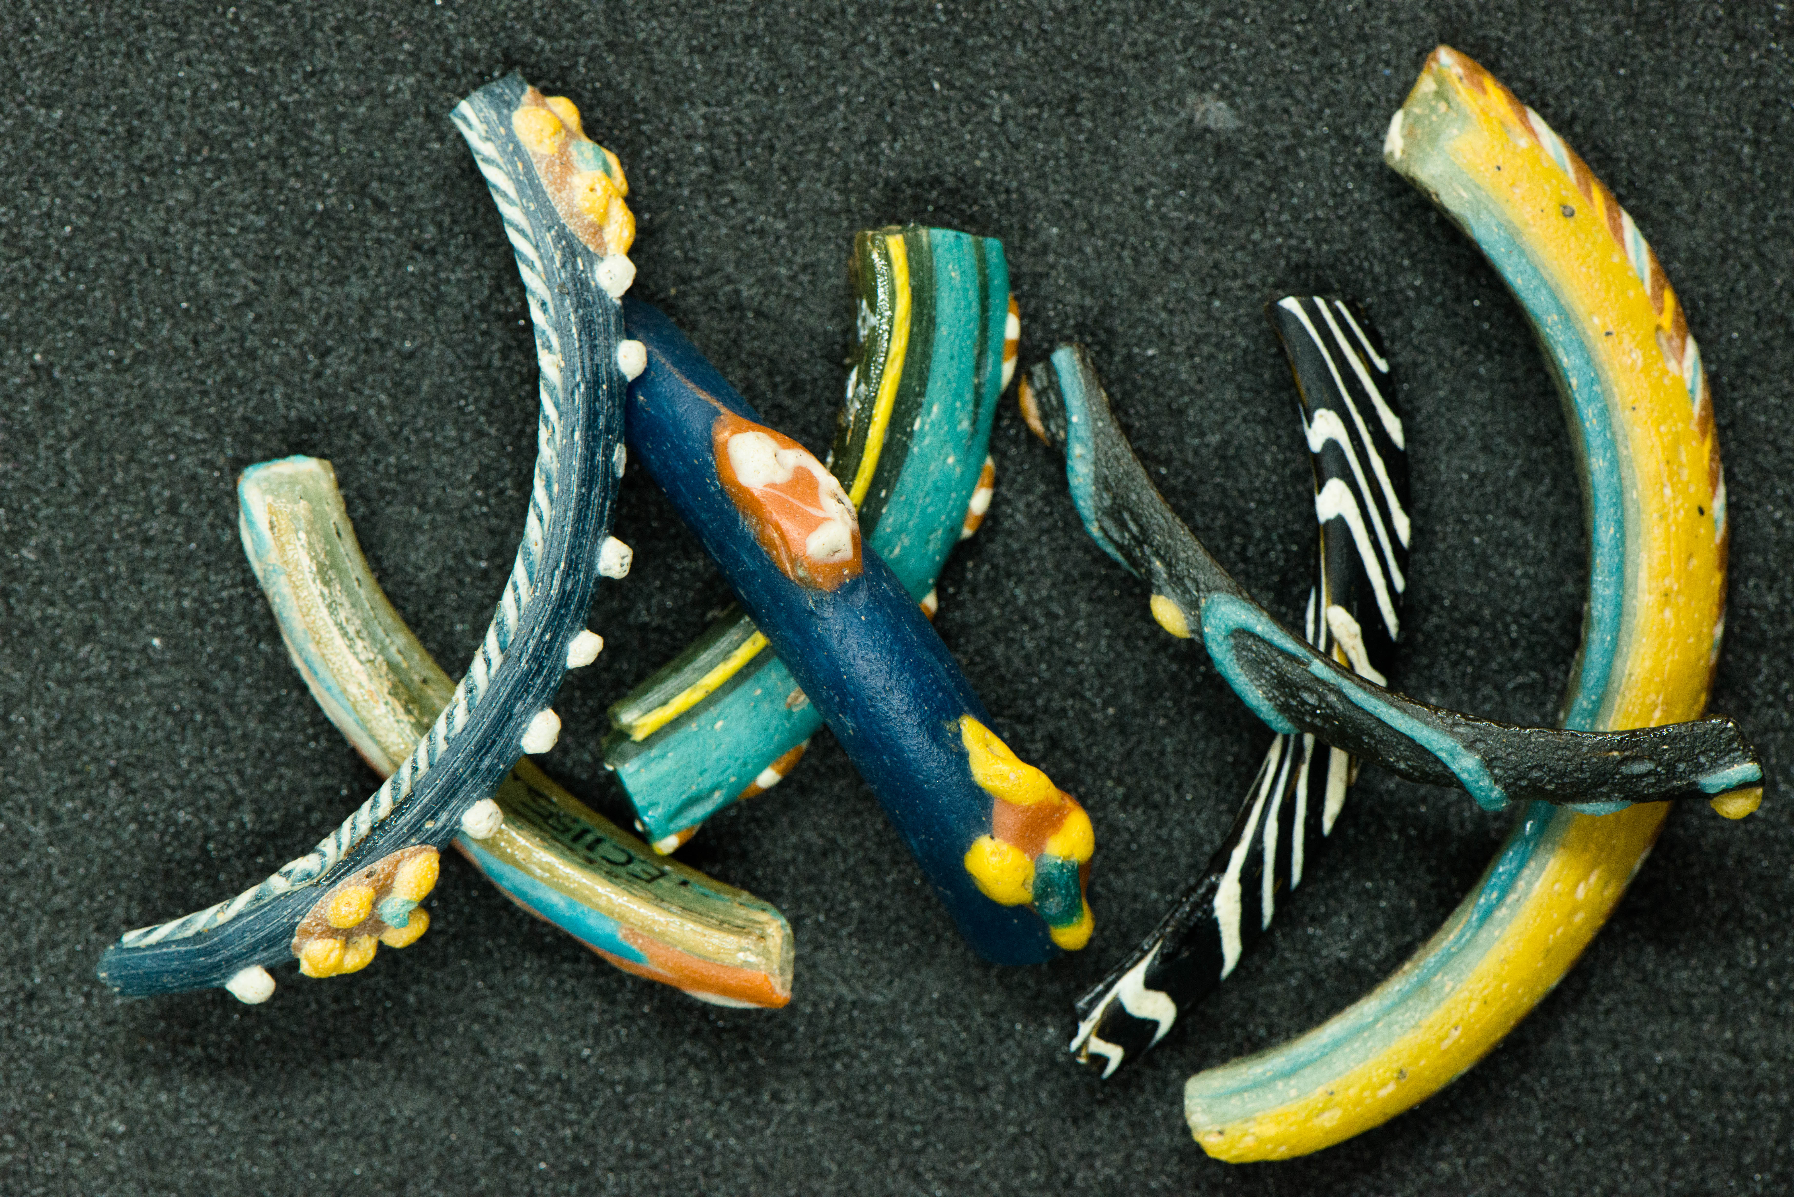
During the Islamic Period glass bracelets were worn, many at a time and often with metal bracelets. Fragments are often found on domestic sites. They are known from Yemen, Egypt and Syrio-Palestine.

Glass bracelets in Egypt are known as early as the time of Amenophis II, though are extremely rare prior to the third century AD. They are most common between 1100 and 1500 AD.

The flat interior surface of these bracelets identifies them as probably of the seamless type (Spear 1988, 52). In this manufacturing technique a blob of glass is pierced by a metal rod and then rotated to make it larger.

Several of the bracelet fragments shown here were donated by Mrs Barbara Elder.

Further reading:

Spaer, Maud 1988. The Pre-Islamic Glass Bracelets of Palestine. Journal of Glass Studies, (30) pp. 51–61.
Spaer, Maud 2001. Ancient glass in the Israel Museum: beads and other small objects', Jerusalem: The Israel Museum.
Steiner, M. L. 2008. An Analysis Of The Islamic Glass Bracelets Found At Tell Abu Sarbut. In Steiner, M., Steen, and Franken (eds.) Sacred and Sweet: studies on the material culture of Tell Deir ʻAlla and Tell Abu Sarbut, Peeters. pp. 231–240

Vorderstrasse, T. and Treptow, T. (eds.) 2015. A Cosmopolitan City: Muslims, Christians, and Jews in Old Cairo. The Oriental Institute of the University of Chicago, pp. 195–196.

